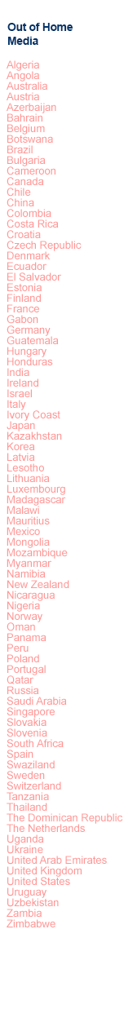

Innovative roadside DOOH changing Africa’s urban marketing landscape

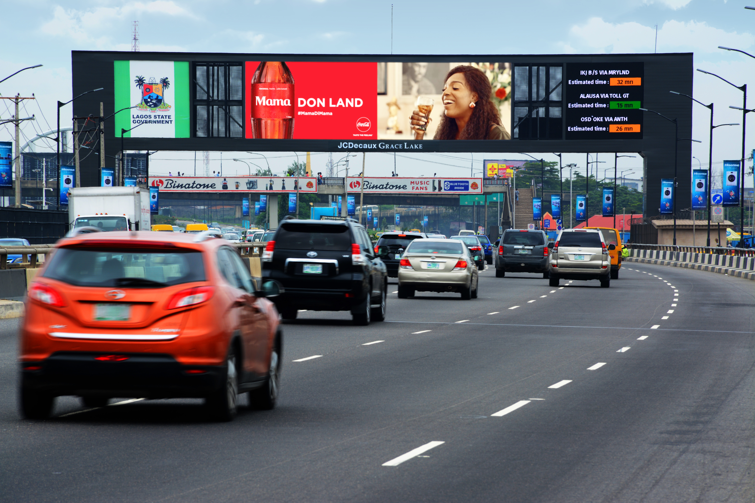

As the number one outdoor advertising company worldwide, JCDecaux is taking roadside digital signage to new heights through its pioneering, client-centred offerings. With 29,000 digital panels in 40 countries globally, JCDecaux’s commitment to research and development has accelerated digital advertising innovation.
Rolled out in Lesotho, Tanzania, Zambia, Botswana, Swaziland, Angola, Zimbabwe, Nigeria, Mozambique and South Africa’s largest cities, all JCDecaux’s roadside digital OOH propositions have the capability of flighting real time, location-based adverts, dynamically applied using daytime, weather conditions and multiple API’s. Dynamic application far exceeds the standard capability of simple ad loops and brings unprecedented messaging flexibility to the digital out of home medium.
Working with city planners, from initial design to regulatory compliance and maintenance, each digital sign location is selected based on density changes in each city specific context. Through harnessing GIS location intelligence and real-time data feeds from its installed camera network, JCDecaux provides advanced advertising solutions for marketers.
African cities will double in population by 2050
The Sub-Saharan Africa media landscape is evolving at a screaming pace driven by rapid urbanisation and a growing youth bulge. The expanding availability of the internet and mobile telephony, and unrelenting fragmentation of traditional media is making the role of targeting audiences a lot more complex than before. Not surprisingly, with a median age of 19.4 years, Africa’s social media adoption has led the use of the internet.
All JCDecaux’s roadside digital screens now have the capability to integrate with social media. Distributing content on entertainment, culture, news and more, the digital platforms provide an enhanced experience for residents and travellers. They offer an immediate opportunity to not only amplify a campaign through engagement and interaction, but the ability to serve the right advert to the right person at the right time in the right location.
To break out of the urban clutter, JCDecaux recently upgraded its 15panel roadside digital network in Lusaka, incorporating mobile into its digital screens. For the first time, local marketers can target city audiences using behavioural profiles augmented with location intelligence. This flexibility in outdoor planning has made it possible to introduce innovative sales packages for brands. We know that dynamic ads work. Running a digital ad campaign increases sales by 10%. Running a digital ad with contextual content increases sales
by a further 8%.

This approach follows on the heels of a successful World Oral Health Day campaign flighted in Johannesburg using moderated social media posts from consumers, linked to a call-to-action brand campaign. Twitter and Facebook messages were calibrated to animate images on the digital screens, creating high engagement through personalisation of the campaign and the inclusion of consumers.
Mobile internet and out of home are a powerful combination. Consumers exposed to mobile internet and out of home are showing a 3 to 5 times uplift in drive-to-store vs unexposed consumers. Mobile click through rates increase by up to 15% when supported by out of home. In WARC studies, up to 46% of US consumers used a search engine as a result of seeing an out of home advert.
Assisting commuters in Africa’s largest city
With its global approach of long term partnership with cities, JCDecaux invested in outdoor urban services that enhance daily life for an increasing number of residents in Lagos. JCDecaux Grace Lake, the Nigerian OOH leader created a digital traffic information system named LATIS for Lagos. It consists of a network of 94 square metre digital traffic arches, with an integrated 25 square metre face which provides advertising complemented with real time traffic information to commuters at strategic driving decision points across the city. Traffic is a major issue in Lagos, Africa's biggest city and the economic capital of the country. Dominance across the city’s key arterial routes has increased advertiser recall.

JCDecaux's innovations meet four criteria: quality, style, functionality and environmental performance, which means adhering to eco-friendly design (strength, durability, low energy consumption and the use of recyclable materials). Only the longstanding multidisciplinary expertise offered by JCDecaux team of 120 engineers and technicians working in R&D can meet such exacting requirements.

JCDecaux has several cost effective roadside digital packages that can be customised locally or regionally to match specific target demographics. Now what can we do for you? To find out more contact ZA_SASales@jcdecaux.com

About JCDecaux in sub-Saharan Africa
JCDecaux in sub-Saharan Africa, formerly Continental Outdoor Media until the acquisition by JCDecaux SA (Euronext Paris: DEC) in partnership with Royal Bafokeng Holdings in June 2015, is Africa's leading traditional and digital outdoor advertising company and operates in 20 countries in Africa. The company offers more than 37,000 advertising opportunities within the African continent.

Key Figures for JCDecaux
- 2018 revenue: €3,619m
- JCDecaux is listed on the Eurolist of Euronext Paris and is part of the Euronext 100 and Euronext Family Business indexes
- JCDecaux is part of the FTSE4Good index
- N°1 worldwide in street furniture (528,660 advertising panels)
- N°1 worldwide in transport advertising with more than 210 airports and 277 contracts in metros, buses, trains and tramways (366,000 advertising panels)
- N°1 in Europe for billboards (137,020 advertising panels)
- N°1 in outdoor advertising in Europe (648,570 advertising panels)
- N°1 in outdoor advertising in Asia-Pacific (239,300 advertising panels)
- N°1 in outdoor advertising in Latin America (72,880 advertising panels)
- N°1 in outdoor advertising in Africa (24,170 advertising panels)
- N°1 in outdoor advertising in the Middle East (16,450 advertising panels)
- Leader in self-service bike rental scheme: pioneer in eco-friendly mobility

- 1,061,200 advertising panels in more than 80 countries
- Present in 4,030 cities with more than 10,000 inhabitants
- 13,030 employees

